- Router Config

- Router 1

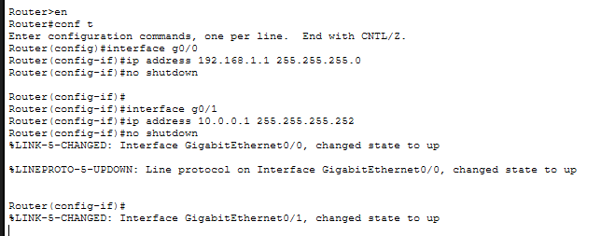

- Router 2
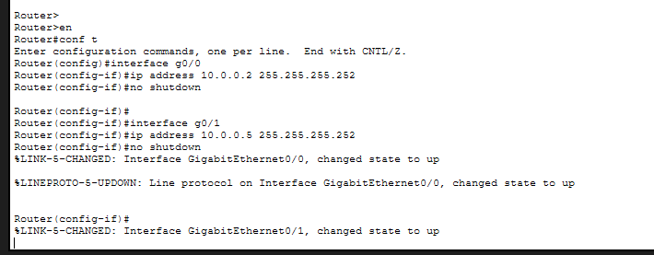

- Router 3
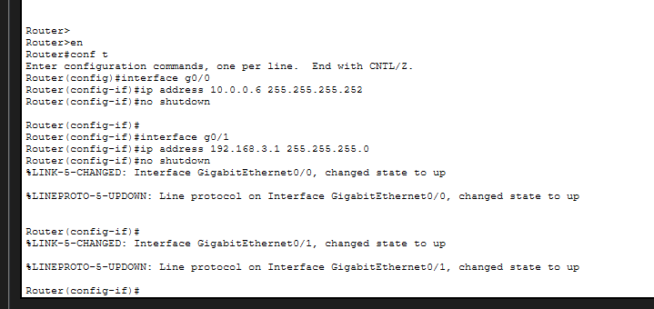
- BGP Config

- Router 1

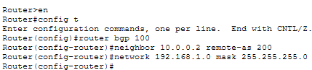

- Router 2

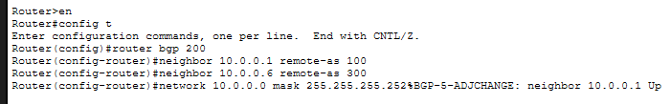

- Router 3

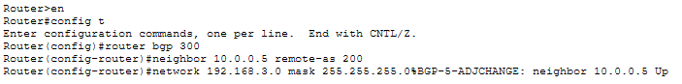

- BGP Verification

- Router 1

